Sumama Rahim
F24BSCS039
Database systems Lab 09 Task Report

Name | Sumama Rahim | Course | Database Systems (CSC-103) | Dprtt/ Program | IET - BSCS
Registration | F24BSCS039 | Instructor | Dr. M. Bilal Shahnawaz | Date | 05/04/2025

Lab 09 Task Report

Problem: Write a report to show the applied queries and their responses.

Solution:
Query:

/*
Apply all of the manipulation queries discussed in the lab to
retrieve, update, and delete the records.
*/

-- 1. Data retrievel using SELECT statement --
SELECT *
FROM Employees;
Response:
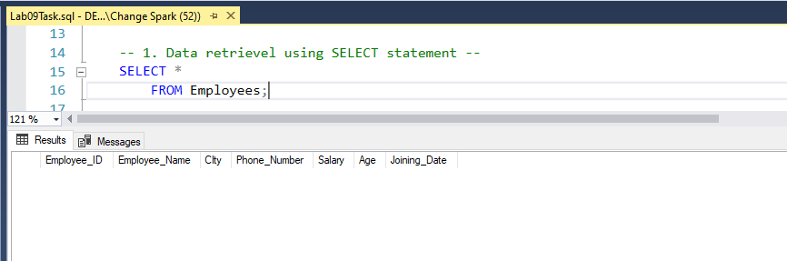
NOTE: No records are added at this time.
Query:
-- 2. Data insertion using INSERT statement --
INSERT INTO Employees (Employee_ID, Employee_Name, City, Phone_Number, Salary, Age, Joining_Date)
VALUES
(101, 'Ali', 'Islamabad', 0323423, 90000, 27, '2024-03-02'),
(102, 'Sameer', 'Lahore', 0342322, 85000, 26, '2023-07-02'),
(103, 'Khan', 'Karachi', 0342331, 79000, 25, '2023-05-02'),
(104, 'Saad', 'Peshawar', 0334320, 95000, 29, '2022-01-02');

PRINT 'Records successfully inserted';
Response:
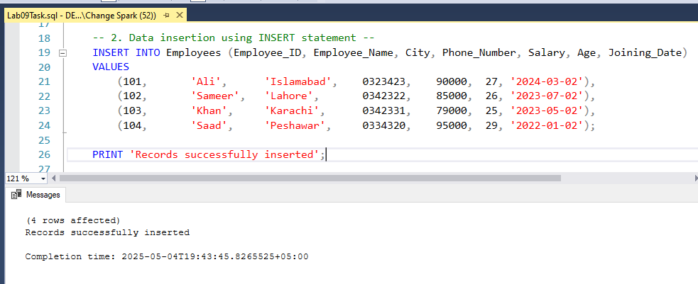

After executing the above query, the affected table is below.
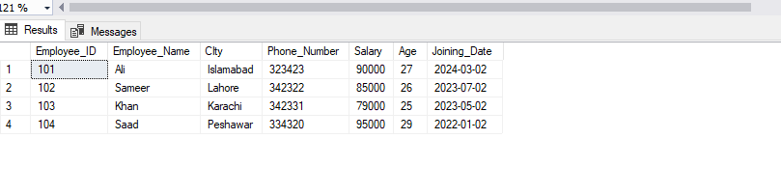
Query:
-- Inserting Data Only in Specified Columns --
INSERT INTO Employees (Employee_ID, Employee_Name, City, Phone_Number, Salary, Age, Joining_Date)
VALUES
(105, 'Naveid', 'Quetta', 0323997, 92000, 26, '2024-01-02');

PRINT 'New record inserted successfully';
Response:
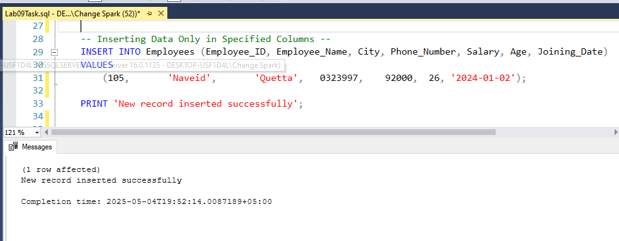

After executing the above query, the affected table is below.
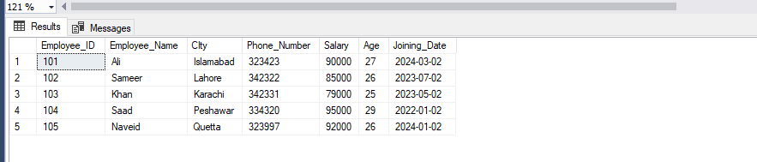

Query:
-- Trying to add another record --
INSERT INTO Employees (Employee_ID, Employee_Name, City, Phone_Number, Salary, Age, Joining_Date)
VALUES
(106, 'Kashif', '2024-01-02'); -- This won't be recorded
Response:
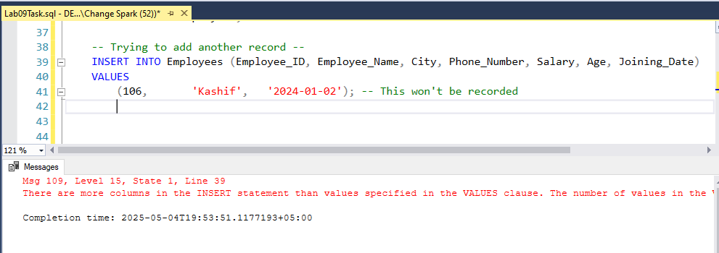

Query:
-- 3. Update Data using UPDATE statement --
UPDATE Employees
SET Employee_ID = 114, Employee_Name = 'Saim'
WHERE Employee_ID = 104;
PRINT 'Employee ID and Name Updated';
Response:
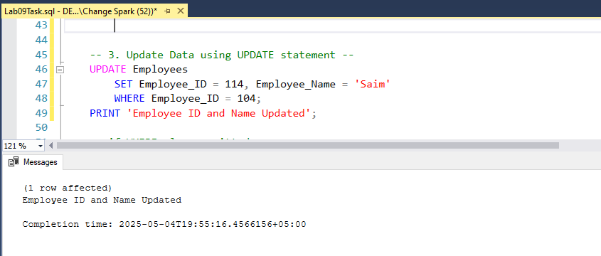

After executing the above query, the affected table is below.
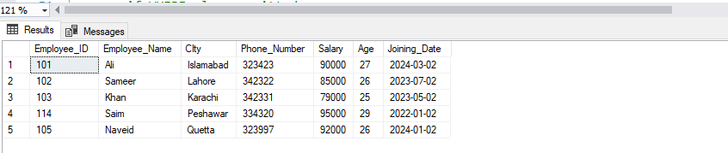
Query:
-- if WHERE clause omitted --
UPDATE Employees
SET Age = 29;
PRINT 'Age updated for all';
Response:
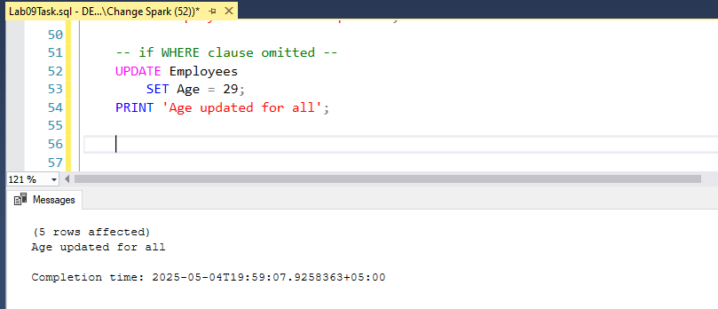

After executing the above query, the affected table is below.
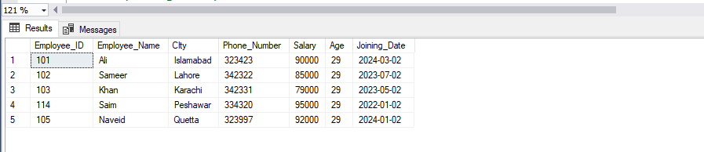
Query:
-- updating multiple records --
UPDATE Employees
SET Age = 31
WHERE City = 'Karachi'; -- it will update all when city = Karachi
Response:
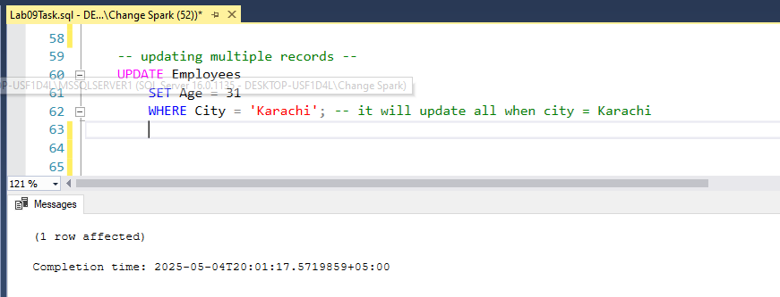

After executing the above query, the affected table is below.
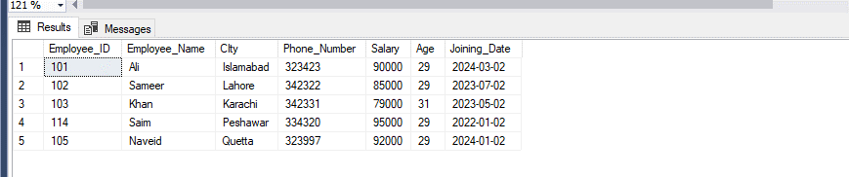
Query:
-- 4. Delete Data using DELETE statement --
DELETE FROM Employees
WHERE Employee_Name = 'Naveid';
PRINT 'Record has been deleted Successfully';
Response:
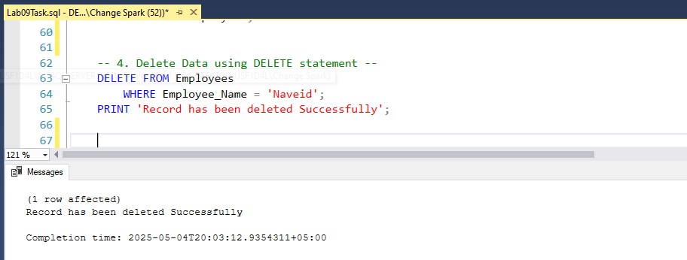

After executing the above query, the affected table is below.
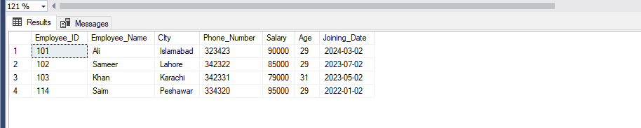

Query:

-- Omitting WHERE Clause --
DELETE FROM Employees;

Response:
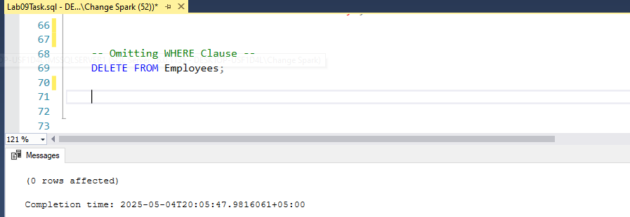

After executing the above query, the affected table is below.
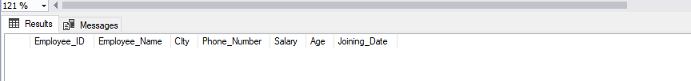

THE END

